Growth Charts – Girls (Determining SGA / AGA / LGA)

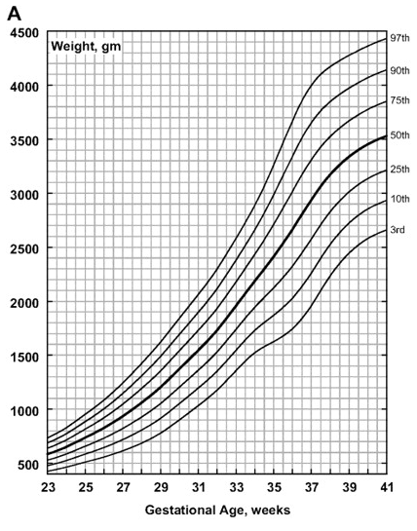 | 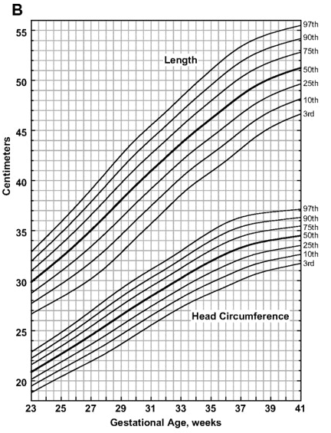
SGA = below 10th % LGA = above 90th % | Olsen I E et al. Pediatrics 2010;125:e214-e224

Growth Charts – Boys (Determining SGA / AGA / LGA)

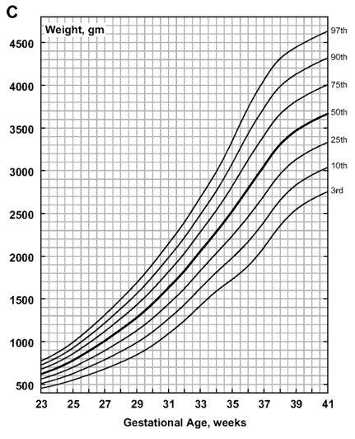 | 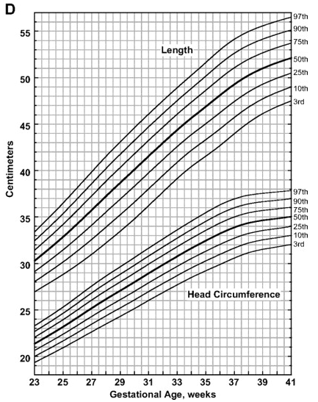
SGA = below 10th % LGA = above 90th % | Olsen I E et al. Pediatrics 2010;125:e214-e224

